An Introduction to Creating Accessible Content
What is Web Accessibility?
The World Wide Web Consortium (W3C) Web Accessibility Initiative (WAI) defines web accessibility as the following: “… Web accessibility means that people with disabilities can perceive, understand, navigate, and interact with the Web, and that they can contribute to the Web.” (Source: https://www.w3.org/WAI/intro/accessibility.php)
Who is Affected by Web Accessibility?
Web accessibility addresses people with several types of disabilities, including:
Vision disabilities | Auditory disabilities | Mobility impairments
Cognitive disabilities | Neurological disabilities | Temporary disabilities

Beyond people with disabilities, web accessibility affects everyone. We all benefit from accessible websites.
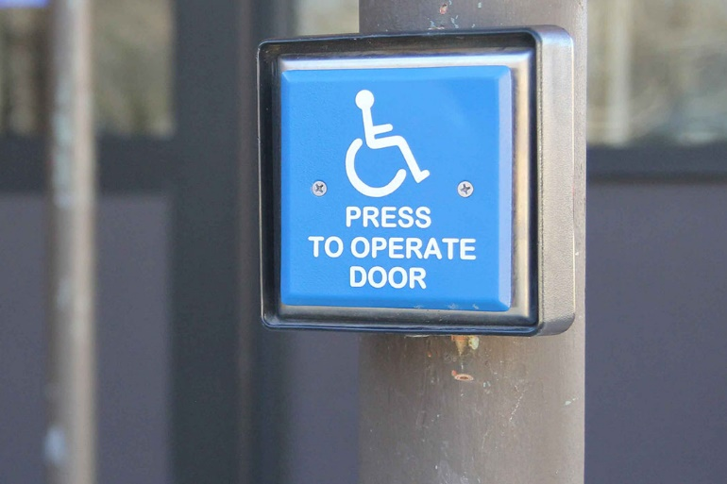 | Think of physical accessibility. We’ve all used an automated door button before, right? Even if we’re not always reliant on a button to open doors, they’re still helpful when our hands are full or if we’re traveling in a big group.  Photo credit: Cooper Avery

What Makes a Website Accessible?
The 4 Principles of Accessibility
As you build a website or app, or you create digital content, keep in mind the 4 principles of accessibility; everything digital must be: perceivable, operable, understandable, and robust. You can remember these with the acronym “POUR.”
Principle | Definition | Examples
Perceivable | Information and user interface components must be presentable to users in ways they can perceive. | Alternative text, video captions, high color contrast
Operable | User interface components and navigation must be operable. | Keyboard accessible, navigable (e.g. use headings), providing enough time
Understandable | Information and the operation of user interface must be understandable. | Readable, predictable, providing input assistance
Robust | Content can be interpreted reliably by a wide variety of user agents, including assistive technologies. | Compatible, adaptable, clean code

Keep the following graphic handy as a reminder of the 4 principles.
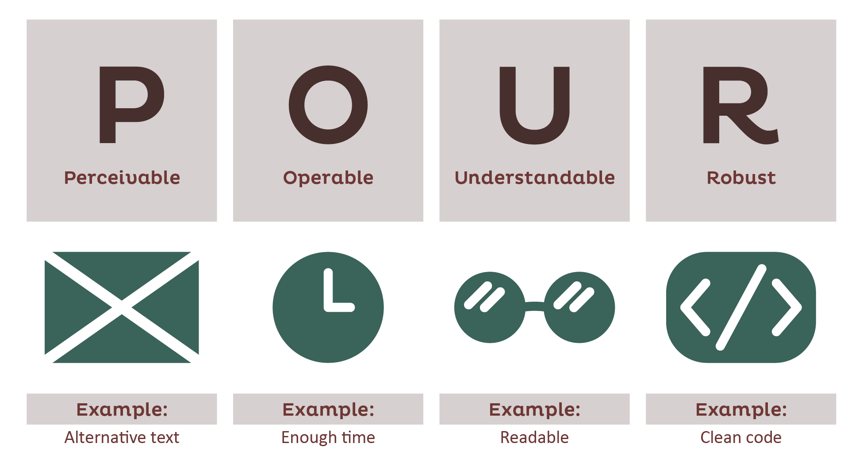
Creating Lists
Accessible text is broken into shorter paragraphs and sentences. Lists are great for breaking up long sentences and ideas. This helps people with cognitive and visual disabilities, people with lower levels of education, and all of us when we’re scanning through for just the highlights.
There are two types of lists: unordered (bulleted) lists, and ordered (numbered) lists. You’ll want to choose a type of list based on the information you’re presenting and whether order matters.
You might want to create a list when any of the following is true: you have a list of parallel items or thoughts; you have a page full of paragraphs and long-form prose; you want to draw attention to a few key points.
To create a list in Microsoft Word, follow these steps: 1. Select the text you want in the list. 2. Click either the “Bullets” icon or the “Numbering” icon in the Paragraph section of the Home tab. 3. Nest appropriate sections of the list. 3. a. Highlight the lines you want to nest. 3. b. Hit the “Tab” button on your keyboard. 4. Enjoy your list!
Further Reading
Click here for an introduction to web accessibility from WebAIM.

